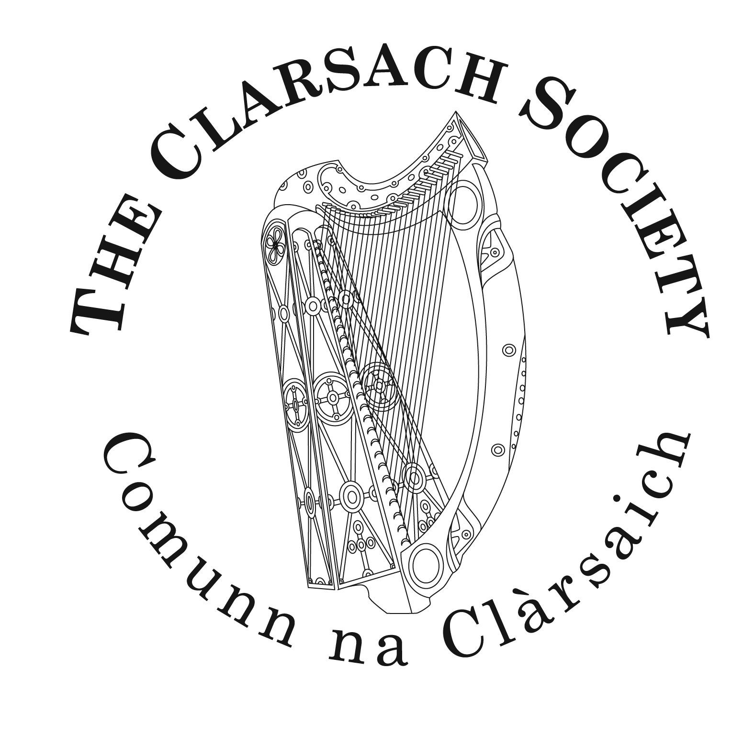

Bursary Application Form

Full name of applicant*:

Street address:

Town/City:

Postcode:

E-mail:

Telephone:

I am a current member of the Branch of The Clarsach Society.

*If applicant is under 18 years of age:

Age:

Parent/guardian's name

Parent/guardian's signature:

Sponsor's name (see 5b below):

Sponsor’s address:

Please state your reason(s) for applying for this bursary:

If successful, how would you use the award, and what benefit(s) would this bring you?

TERMS AND CONDITIONS

1. Any member of The Clarsach Society, with the exception of Trustees, can apply:
- Unsuccessful applicants may re-apply in future years.
- Successful applicants may not re-apply.
2. The Bursaries are intended to benefit and encourage promising players at any level who have limited resources, financial or otherwise.

3. The awards will be a sum fixed by The Society’s Music Committee (up to £500) for use towards the cost of tuition and accommodation at an approved course with a Scottish content (e.g. Edinburgh International Harp Festival). When appropriate, the bursary may take the form of the use of a harp provided free for one year, possibly extending for up to 3 years.

4. Applicantions will be given consideration by The Society’s Music Committee.

5. All entries must be submitted with:
- A completed application form.
- A confidential recommendation written by a sponsor: being a recognised music teacher, (who need not be a clarsach teacher) or other person with appropriate knowledge able to comment on the applicant’s general potential ability.
6. Applications must be submitted by November 1st each year.

7. Successful applicants will be asked to report on a fixed date(s) on how they have used their bursary or use of a harp for our records.

8. Completed application forms and sponsor recommendations should be emailed privately to office@clarsachsociety.co.uk by 5pm on November 1st in the year of application.

9. If you have any queries or special requirements, contact the National Office via email office@clarsachsociety.co.uk or telephone +44 (0)131 554 0212.

